
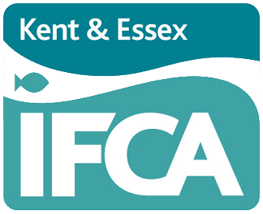
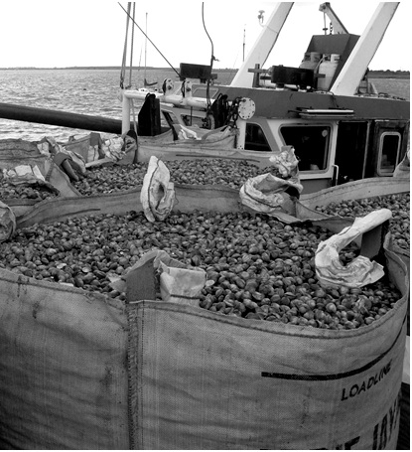
CONSULTATION 2
Review of current management, and development of future management, related to the cockle fisheries within the Kent and Essex IFCA District.
Contents
Background information and guidance 4
Framework options 7
NEW JAMAICA Option 7
NEW HAITI Option 9
NEW BERMUDA 7 Option 11
NEW BERMUDA 28 Option 13
Small-scale flexible permit byelaw fishery 14
Comparing the options 16
Questionnaire 20
Appendix 1 31
Appendix 2 Detail of the 7-year licencing and review cycle 27
Appendix 3 Detail of the licence application process 28
Appendix 4 The criteria used to evaluate applications 29

Book one-to-one officer support slot between the 27-29th July
Senior KEIFCA officers have set aside three days at the beginning of the consultation (27-29th July) where stakeholders can arrange a time to chat with an officer, who can explain or run through the consultation document individually. One-to-one officer support is aimed at supporting stakeholders navigate the complex legal area of licence application, which the Listening Phase highlighted was poorly understood. Stakeholders will be able to book a specific time to talk to officers, either in person at the Ramsgate or Brightlingsea office, or over a Zoom/Teams/Facetime call. This session will just be used to explain the consultation document and answer any questions about the document. The one-to-one session will not collect evidence from stakeholders, with stakeholders told to either complete a consultation document or to attend an oral evidence session.

How to respond to this consultation
This consultation is split into four proposed options. Each option is considered individually with a chart and background information provided for that option.
The questionnaire in this consultation should be completed with reference to the background information provided here.
Please email your completed questionnaire to info@kentandessex-ifca.gov.uk. The closing date for receipt of questionnaires for this consultation is:
16th September 2022
Any responses received after this date will not be considered.

How to get more information
- Website: https://cocklereview.kentandessex-ifca.gov.uk
- Email: info@kentandessex-ifca.gov.uk
- Telephone: 01843 585310

Privacy Policy
KEIFCA has a legal duty to manage the sustainable exploitation of sea fisheries resources within its District. These are set out in the Marine and Coastal Access Act 2009. The Authority cannot deliver this duty without processing personal data. For full details of our privacy policy go to our website https://www.kentandessex-ifca.gov.uk/privacy-policy.
How we use your personal information
We collect and use this information in order to:
- facilitate your participation in our consultation and engagement activities
- understand your views about a particular topic or KEIFCA activity
- analyse consultation and engagement activity
- communicate information to you about engagement and consultation opportunities, events and other initiatives, if you have requested to be kept informed

How long your personal data will be kept
We will hold any personal information provided by you as part of engagement or consultation activity for up to six years following the closure of a consultation.
Reasons we can collect and use your personal information
For engagement and consultation activity carried out in respect of this consultation we rely on UK GDPR Article 6(1)(e): ‘processing is necessary for the performance of a task carried out in the public interest' and Article 6(1)(c) ‘for compliance with a legal obligation to which the controller is subject’ as our lawful basis.
Information provided to the IFCA through all its consultations/listening phases will be provided in its entirety to Members of the IFCA. Redacted copies of this information (i.e., personal/identifying details are removed) will be made available on our website http://cocklereview.kentandessex-ifca.gov.uk/. No personal information which can identify you, such as your name or email address, will be used in producing reports unless you specifically allow us to. We will follow our Data Protection policies to keep your information secure and confidential.

Background information and guidance

“KEIFCA will seek to maintain both sustainable cockle fisheries in the KEIFCA district as well as the wider ecosystem it relies on; through this, support a viable local cockle industry, recognising its important long-term contribution to coastal communities, and providing skilled employment.”
Overview of cockle management development process
Legislative Framework Phase | Consultation 1  Agree initial framework model outlines  (24 March – 9 May 2022) | The first step reviewed and evaluated a range of different management framework models for managing cockle fisheries within the KEIFCA District. The key features included the size and shape of any specific management zones, the type of fishing gear (e.g. suction dredge or other fishing method), whether access to an zone would be limited and if so to what kind of number/ range of licences or permits would likely be issued. Finally, whether the IFCA would use a regulating order or byelaw to manage the area.  Following an extensive consultation and a special Authority meeting, the Authority voted for three framework models to be developed further in Consultation 2; New Jamaica, New Haiti and New Bermuda (all these options included a commitment to make a new regulating order). The Authority also agreed to develop a small-scale fishery in the area outside the regulating order, using the current flexible permit byelaw rather than running a small-scale trial.
Legislative Framework Phase | Consultation 2  Agree access arrangements for framework models and a single framework to take to next stage  (22 July – 16 Sept) | Consultation 2 explores the different methods, systems, or criteria that the Authority might use to manage, limit or control access to a specific cockle management zone. Building on the decisions made in Consultation 1, the wide range of different possible access arrangements or criteria for potential licence holders can be thoroughly discussed and evaluated within the context of each agreed framework model.  This is a complex legal area with very far-reaching long-term consequences which can not only impact current fishermen, but also has the potential to impact a generation of future fishermen. The Listening Phase highlighted that this was an area poorly understood by fishers outside of the current cockle fishery and it was important to spend time to clearly work though the mechanisms, outcomes and impacts upon different sectors, of different possible access arrangements. At the end of this step in the process the Authority would agree the final framework model and access arrangements/ criteria to develop further during the technical development phase.
Technical detail development Phase | Consultation 3  Agree key features and detail of the agreed framework model.  (13 Dec 22 – 31 Jan 23) | One of the key issues that has been raised throughout the Listening Phase are whether operators that acquire a licence could transfer that licence in the future either to an individual like a family member or via the purchase of their company. Having a clear management framework model with agreed access arrangements/ criteria will help inform this decision and allow a focused debate on what can be a very emotive discussion with very strong views on either side.  Other important areas of detail that would need to be discussed and agreed include the timing and scope of any review of the legislation, agreeing any fine detail of the access arrangements/ criteria and finalising boundary and fishing area coordinates.
Technical detail development Phase | Consultation 4  Agree operational technical details and final wording  (10 May – 20 June 2023) | The fourth consultation focuses on the practical day-to-day details of how the cockle fishery will be managed and run. This step would review regulations concerning the gear and equipment used in the fishery, fishing trip details (amount per trip, landing procedure etc) and management procedures/ management plan. There would also be an ambition to have a draft wording of the proposed legislation and a draft Impact Assessment for comment.

Statutory consultation phase
Once the final text of the proposed option has been agreed by the KEIFCA members then the legislation will be taken through the appropriate statutory consultation and confirmation process for a Regulating Order.

Overview
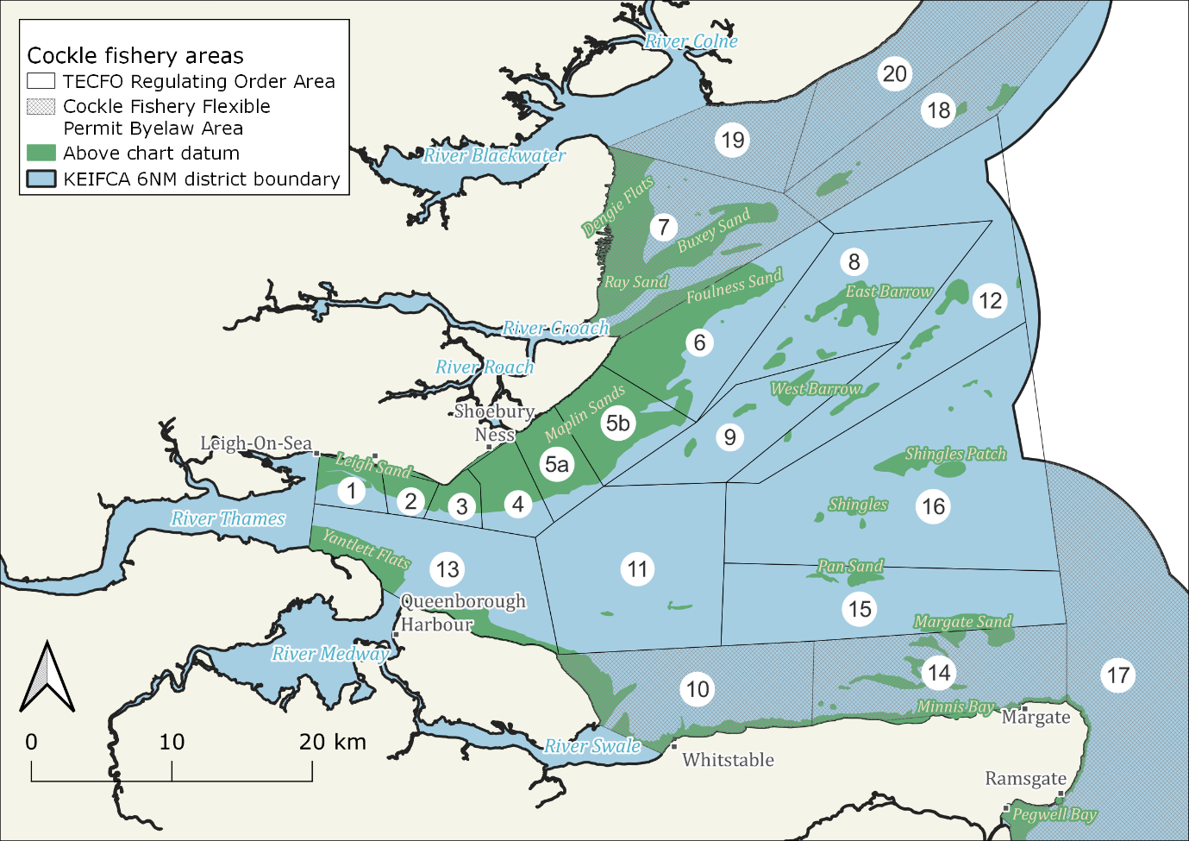
Cockle stocks within the KEIFCA District are currently managed under two different legislative management regimes. The cockle stocks in the majority of the District are managed under a KEIFCA byelaw called the Cockle Fishery Flexible Permit Byelaw (CFFPB). However, the main production beds, which are contained within a specific area of the Thames Estuary, are managed by KEIFCA under a Statutory Instrument called the Thames Estuary Cockle Fishery Order 1994 (TECFO).
On the 28 September 2024 the TECFO, which started in 1994, will end. Although this is two cockle seasons away, the ending of the TECFO provides an opportunity to review how cockle stocks are managed, as well as the underpinning legislation, across the District including within the current TECFO area.
Figure 1. Map of Thames Estuary showing current KEIFCA cockle spatial management areas
The process of reviewing, and then developing, future management started with an evidence-gathering exercise or ‘Listening Phase’ where KEIFCA gathered views and ideas from a wide range of stakeholders. Specifically, we wanted to understand what works well within the current fisheries management systems and where stakeholders believe changes need to be made. The Listening Phase ran from the 27 September until the 8 November 2021 and feedback from the Listening Phase provided the starting point for Consultation 1 which reviewed numbers of fishing vessels, gear type, access criteria and type of legislation and areas of management.
Following an extensive consultation process, seven options were put to the vote at a special Authority meeting held on the 14 June 2022 and three options were selected to go through to the next step in the process, Consultation 2.
The options outlined in this consultation reviewed a range of different systems for issuing licences and looked in detail at the use of different types of track record as a mechanism to issue future licences. Members reviewed feedback from the Listening Phase as well as the evidence in
- Spatial Distribution and Stock Review of cockles in the Kent and Essex district Report
- Economic Performance Report – Seafish
- Review of environmental impacts of hydraulic suction dredging for cockles - KEIFCA District
Using this information, members then agreed the detailed options that would be included in this consultation document. These detailed options are laid out on the following pages, and each option can be read as a stand-alone piece of information or with reference to the other options. All should be read with reference to the small-scale flexible permit fishery information on page 14 and 15 as well as the appendices attached to the main document.

What happens next?
The consultation runs from 22 July until the 16 September 2022 and includes an oral evidence session as well as this consultation document. The oral evidence sessions will run on the 8th and 9th September and can be booked by emailing directly or booking on the http://cocklereview.kentandessex-ifca.gov.uk/ website.
Using the evidence from the consultation replies, the feedback for each option will be compiled. In addition, a technical assessment of each option will be developed by KEIFCA officers using the evaluation criteria as a framework, this enables a comparison of each option against the Vision. The documents produced from this process will be put on to the http://cocklereview.kentandessex-ifca.gov.uk/ website using the same procedure as normal Authority papers.
An Authority meeting is scheduled for the 20 October 2022 at which KEIFCA officers will outline each option and there will be an opportunity for members of the public to make comments on each option (following the procedure in the standing orders). Members will then consider the feedback and comments from stakeholders as well as a technical assessment from KEIFCA officers before voting on the option to take forwards into Consultation 3. In Consultation 3 the process of transforming the framework into detailed legislation starts, and the topic of license ownership is addressed.

Framework options

NEW JAMAICA Option
This option divides the cockle fisheries within the District into two zones; one of which would be run using a regulating order and the rest of the District which would be run using a flexible permit byelaw. Under this option a new regulating order (Outer Thames Regulating Order 2025 (OTRO 2025) would replace the current TECFO. The Northern and Eastern boundaries are similar to the current TECFO boundaries, enclosing the main cockle beds of the Maplin Sands complex and managing these beds as a coherent biological unit, however the Southern boundary would be positioned further north (see Comparing the Options section) and not include areas like the Margate Sands (Area 15), and Scrapsgate (Area 13). This would mean the flexible permit byelaw area would include potentially high yielding but highly variable cockle beds of large cockles in the Margate Sands (Area 15) and the relatively consistent but lower level productivity beds of the Buxey and the Dengie (Area 7) and Area 13, with the potential of an emerging clam fishery in both of those areas.
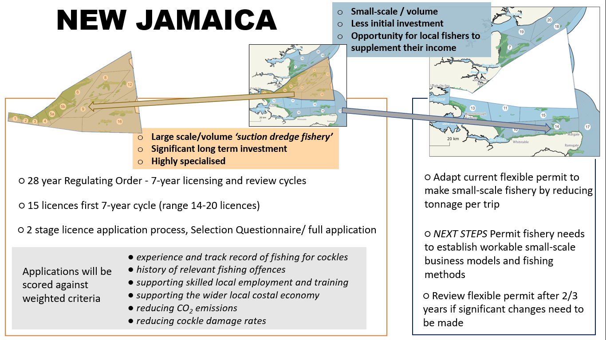

Structure of the Outer Thames Regulating Order 2025 (OTRO 2025)
The new regulating order would be designed to run for 28 years (2024 - 2052) and be split into four 7-year licencing cycles. The current consultation process will determine the number of licences issued for the first 7- year cycle (2025 – 2032) and thereafter the number of licences for each subsequent 7-year cycle will be decided upon by the Authority after undertaking a thorough review, starting about 18 months prior to the start of the next 7- year cycle (see Appendix 1 for more detail).
It is proposed that the process for issuing licences should follow, where possible, the standard Kent County Council process for issuing licences or contracts where applicants are invited to complete a Selection Application (SA) with successful applicants then invited to complete a more detailed Full Application (FA) (See Appendix 2 for full application process).
Applications will be assessed by an Applications Panel using the details and evidence provided covering areas such as experience and track record of fishing for cockles, history of relevant fishing offences, supporting skilled local employment and training, supporting the wider local costal economy, and taking steps to reduce CO₂ emissions and cockle damage rates (See Appendix 3 for full details).

Consideration of the number of licences to be issued in the new Regulating Order
After reviewing feedback from the Listening Phase as well as considering the history, experience and environmental impact of suction dredge cockle fisheries, Authority members concluded that a large increase in suction dredgers could have a significant negative impact on the long-term sustainability of the Thames cockle fishery. In response to this, members agreed that it was important to cap or limit the number of suction dredge licences that would work in the potential OTRO 2025 area. In Consultation 1 members agreed to a range of 14-20 suction dredge licences within the new regulating order.
As part of developing Consultation 2, members reviewed and weighed up environmental and economic information concerning the number of licences to issue for the first 7-year cycle. This was a very difficult decision, especially as the majority of the fishery takes place within internationally important Marine Protected Areas. However, the Authority agreed to the issuing of 15 licences for the first 7-year cycle (2025-2032), with the requirement that significant monitoring and evidence gathering should be put in place to help inform the licence review process in 2032.
Both the TAC and the value of cockles landed can vary significantly from year to year - the Seafish-produced ‘Economic Performance Report’ gives an overview of this variation over a 10-year period. Issuing 15 licences would mean that the annual TAC would be divided evenly between 15 license holders rather than between 14 licence holders, as done presently, resulting in a proportionate reduction in tonnes of cockles landed per licence. In a similar way but for the environment, the ‘Review of environmental impacts of hydraulic suction dredging for cockles – KEIFCA District’ document attempts to look at the impacts of increasing the number of licences on the wider ecosystem (within an annual TAC system where the TAC was split evenly between the number of licences issued). Both these documents are available on our consultation website http://cocklereview.kentandessex-ifca.gov.uk/.

The small-scale permit fishery running outside the new Regulating Order
Whilst the detail above provides an outline of the New Jamaica framework and how it affects primarily the area within the OTRO, the option also includes areas outside the OTRO which will be managed using a flexible permit byelaw. The detail of how the small-scale flexible permit byelaw fishery would work around is outlined on pages 14 and 15.

NEW HAITI Option
This option divides the cockle fisheries within the District into two zones; one of which would be run using a regulating order and the rest of the District which would be run using a flexible permit byelaw. Under this option a new regulating order (Outer Thames Regulating Order 2025 (OTRO 2025) would replace the current TECFO. Under this option the boundaries of the new regulating order would be the same as the current Thames Estuary Cockle Fishery Order 1994 (TECFO 1994) boundary. This would mean that the Margate Sands (Area 15), and Scrapsgate (Area 13), as well as Area 11, would be within the OTRO boundary and come under the management and licensing regime of the new regulating order.
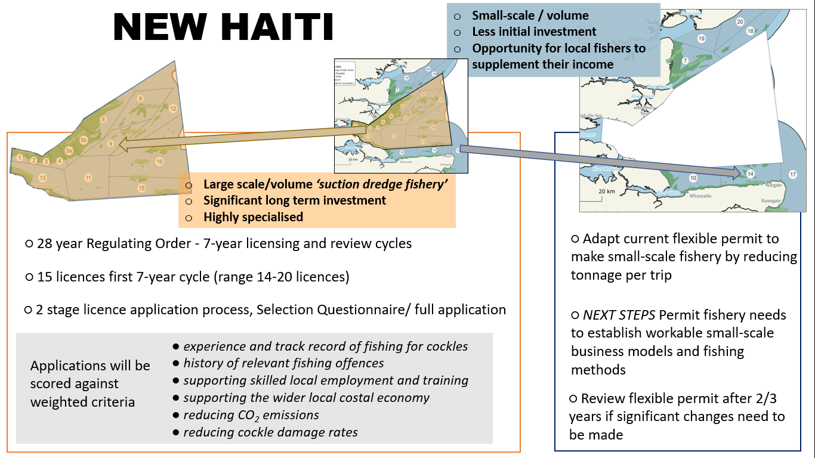

Structure of the Outer Thames Regulating Order 2025 (OTRO 2025)
The new regulating order would be designed to run for 28 years (2024 - 2052) and be split into four 7-year licencing cycles. The current consultation process will determine the number of licences issued for the first 7- year cycle (2025 – 2032) and thereafter the number of licences for each subsequent 7-year cycle will be decided upon by the Authority after undertaking a thorough review, starting about 18 months prior to the start of the next 7- year cycle (see Appendix 1 for more detail).
It is proposed that the process for issuing licences should follow, where possible, the standard Kent County Council process for issuing licences or contracts where applicants are invited to complete a Selection Application (SA) with successful applicants then invited to complete a more detailed Full Application (FA) (See Appendix 2 for full application process).
Applications will be assessed by an Applications Panel using the details and evidence provided covering areas such as experience and track record of fishing for cockles, history of relevant fishing offences, supporting skilled local employment and training, supporting the wider local costal economy, and taking steps to reduce CO₂ emissions and cockle damage rates (See Appendix 3 for full details).

Consideration of the number of licences to be issued in the new Regulating Order
After reviewing feedback from the Listening Phase as well as considering the history, experience and environmental impact of suction dredge cockle fisheries, Authority members concluded that a large increase in suction dredgers could have a significant negative impact on the long-term sustainability of the Thames cockle fishery. In response to this, members agreed that it was important to cap or limit the number of suction dredge licences that would work in the potential OTRO 2025 area. In Consultation 1 members agreed to a range of 14-20 suction dredge licences within the new regulating order.
As part of developing Consultation 2, members reviewed and weighed up environmental and economic information concerning the number of licences to issue for the first 7-year cycle. This was a very difficult decision, especially as the majority of the fishery takes place within internationally important Marine Protected Areas. However, the Authority agreed to the issuing of 15 licences for the first 7-year cycle (2025-2032), with the requirement that significant monitoring and evidence gathering should be put in place to help inform the licence review process in 2032.
Both the TAC and the value of cockles landed can vary significantly from year to year - the Seafish-produced ‘Economic Performance Report’ gives an overview of this variation over a 10-year period. Issuing 15 licences would mean that the annual TAC would be divided evenly between 15 license holders rather than between 14 licence holders, as done presently, resulting in a proportionate reduction in tonnes of cockles landed per licence. In a similar way but for the environment, the ‘Review of environmental impacts of hydraulic suction dredging for cockles – KEIFCA District’ document attempts to look at the impacts of increasing the number of licences on the wider ecosystem (within an annual TAC system where the TAC was split evenly between the number of licences issued). Both these documents are available on our consultation website http://cocklereview.kentandessex-ifca.gov.uk/.

The small-scale permit fishery running outside the new Regulating Order
Whilst the detail above provides an outline of the New Haiti framework and how it affects primarily the area within the OTRO, the option also includes areas outside the OTRO which will be managed using a flexible permit byelaw. The detail of how the small-scale flexible permit byelaw fishery would work around is outlined on pages 14 and 15.

Why are there now two versions of NEW BERMUDA?
At the 14 June Authority meeting, Authority members voted to include the NEW BERMUDA option in the Consultation 2 process. The key component of the NEW BERMUDA option was that the number of licences would be fixed at 14 for the duration of the order. When different access mechanisms were added to the NEW BERMUDA framework Authority members felt strongly that two versions of the NEW BERMUDA option should be included in the consultation and voted for both the New Bermuda 7 option and the New Bermuda 28 option at the Special Authority meeting on the 7 July 2022.

NEW BERMUDA 7 includes the 7-year review cycle as per the NEW JAMAICA and NEW HAITI options already outlined. This would mean that although the number of licences issued would be fixed at 14, every 7 years there would be an open application licence process.

NEW BERMUDA 28 replicates the access system that has been used in the TECFO. Effectively this would create a system whereby the current TECFO licence holders would maintain a licence for the next 28 years and there would be no process or ability to review the number of licences.

NEW BERMUDA 7 Option
This option divides the cockle fisheries within the District into two zones; one of which would be run using a regulating order and the rest of the District which would be run using a flexible permit byelaw. Under this option a new regulating order (Outer Thames Regulating Order 2025 (OTRO 2025) would replace the current TECFO. Under this option the boundaries of the new regulating order would be the same as the current Thames Estuary Cockle Fishery Order 1994 (TECFO 1994) boundary. This would mean that the Margate Sands (Area 15), and Scrapsgate (Area 13), as well as Area 11, would be within the OTRO boundary and come under the management and licensing regime of the new regulating order.
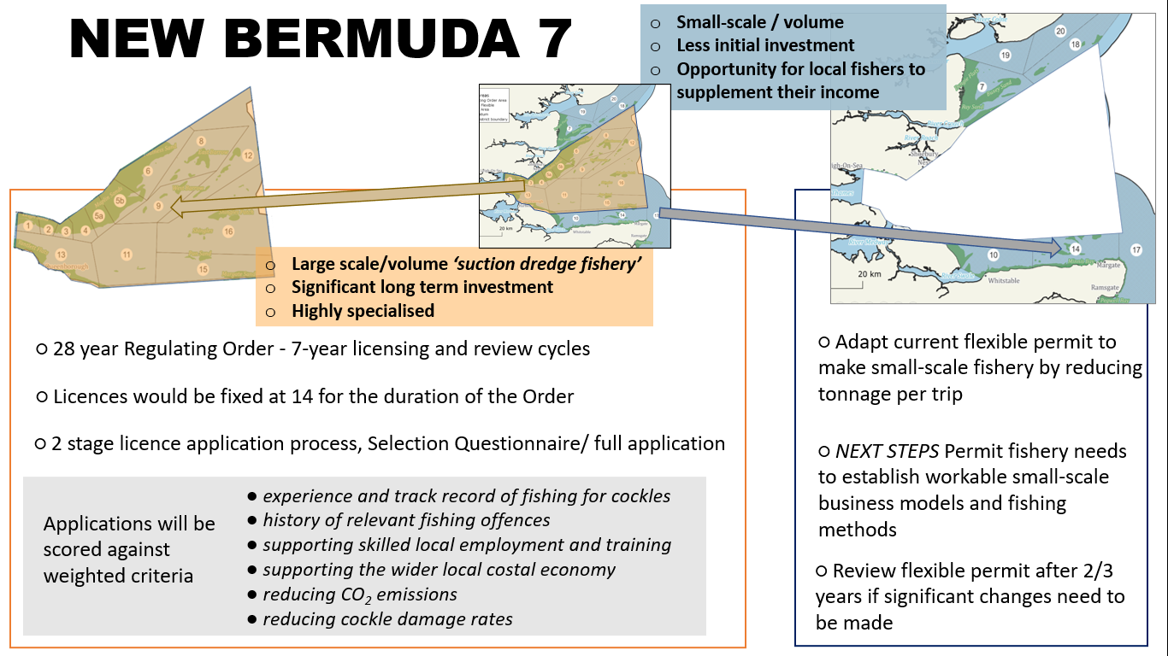

Structure of the Outer Thames Regulating Order 2025 (OTRO 2025)
The new regulating order would be designed to run for 28 years (2024 - 2052) and be split into four 7-year licencing cycles. The number of licences issued throughout the 28-year period of the regulating order will be fixed at 14 licences and there would be no review process or ability to review the number of licences included in the wording of the regulating order. However, this option keeps the same 7-year licencing cycle whereby there is an open licence application process prior to the start each 7-year cycle.
It is proposed that the process for issuing licences should follow, where possible, the standard Kent County Council process for issuing licences or contracts where applicants are invited to complete a Selection Application (SA) with successful applicants then invited to complete a more detailed Full Application (FA) (See Appendix 2 for full application process).
Applications will be assessed by an Applications Panel using the details and evidence provided covering areas such as experience and track record of fishing for cockles, history of relevant fishing offences, supporting skilled local employment and training, supporting the wider local costal economy, and taking steps to reduce CO₂ emissions and cockle damage rates (See Appendix 3 for full details).

Consideration of the number of licences to be issued in the new Regulating Order
After reviewing feedback from the Listening Phase as well as considering the history, experience and environmental impact of suction dredge cockle fisheries, Authority members concluded that a large increase in suction dredgers could have a significant negative impact on the long-term sustainability of the Thames cockle fishery. In response to this, members agreed that it was important to cap or limit the number of suction dredge licences that would work in the potential OTRO 2025 area. As part of the NEW BERMUDA option, Authority members agreed to fix the number of licences for the duration of the regulating order at 14 licences.
While a keeping or fixing the number of licences issued at 14 maintains the current environmental impact of the suction dredge fishery and provides a reliable and significant income to each licence holder, keeping the number of licences issued at 14 for the next 28 years does remove the opportunity for the Authority to review and adapt management if circumstances change in the future. Although the proposed new 7-year licensing cycle does provide a new opportunity for different businesses to enter the fishery, the opportunity would be greater if there was the option to vary the number of licences issued.

The small-scale permit fishery running outside the new Regulating Order
Whilst the detail above provides an outline of the New Bermuda 7 framework and how it affects primarily the area within the OTRO, the option also includes areas outside the OTRO which will be managed using a flexible permit byelaw. The detail of how the small-scale flexible permit byelaw fishery would work around is outlined on pages 14 and 15.

NEW BERMUDA 28 Option
This option divides the cockle fisheries within the District into two zones; one of which would be run using a regulating order and the rest of the District which would be run using a flexible permit byelaw. Under this option a new regulating order (Outer Thames Regulating Order 2025 (OTRO 2025) would replace the current TECFO. Under this option the boundaries of the new regulating order would be the same as the current Thames Estuary Cockle Fishery Order 1994 (TECFO 1994) boundary. This would mean that the Margate Sands (Area 15), and Scrapsgate (Area 13), as well as Area 11, would be within the OTRO boundary and come under the management and licensing regime of the new regulating order. 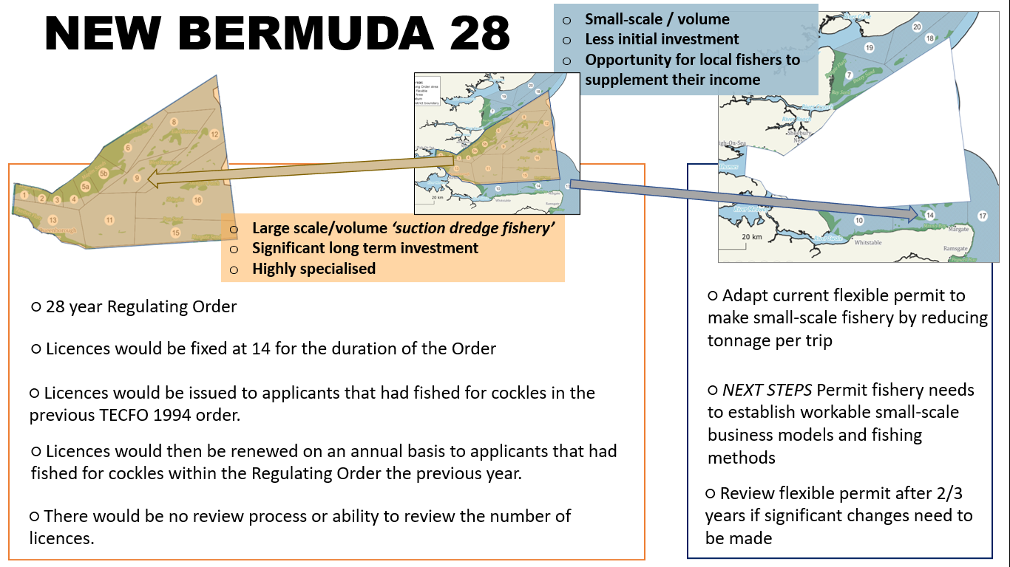

Structure of the Outer Thames Regulating Order 2025 (OTRO 2025)
The new regulating order would be designed to run for 28 years (2025 - 2053) and would not be divided into any licencing cycles. Instead, the same licencing process that is currently used in the Thames Estuary Cockle Fishery Order 1994 (TECFO 1994) would be replicated in the new regulating order. Licences would be issued to applicants that had fished for cockles in the previous TECFO 1994 order. Licences would then be renewed on an annual basis on the prerequisite that the applicant had fished for cockles within the Regulating Order the previous year. The number of licences issued throughout the 28-year period of the regulating order will be fixed at 14 licences. There would be no review process or ability to review the number of licences.

Consideration of the number of licences to be issued in the new Regulating Order
Whilst keeping or fixing the number of licences issued at 14 maintains the current environmental impact of the suction dredge fishery and provides a reliable and significant income to each licence holder, keeping the number of licences issued at 14 for the next 28 years does remove the opportunity for the Authority to review and adapt management if circumstances change in the future. Effectively replicating the TECFO licencing process, 14 licences would provide a very stable long-term opportunity for the businesses with a licence but would deny other businesses an opportunity to harvest from within the regulating order for the 28-year period of the regulating order (2025 – 2053).

The small-scale permit fishery running outside the new Regulating Order
Whilst the detail above provides an outline of the New Bermuda 28 framework and how it affects primarily the area within the OTRO, the option also includes areas outside the OTRO which will be managed using a flexible permit byelaw. The detail of how the small-scale flexible permit byelaw fishery would work around is outlined on pages 14 and 15.

Small-scale flexible permit byelaw fishery
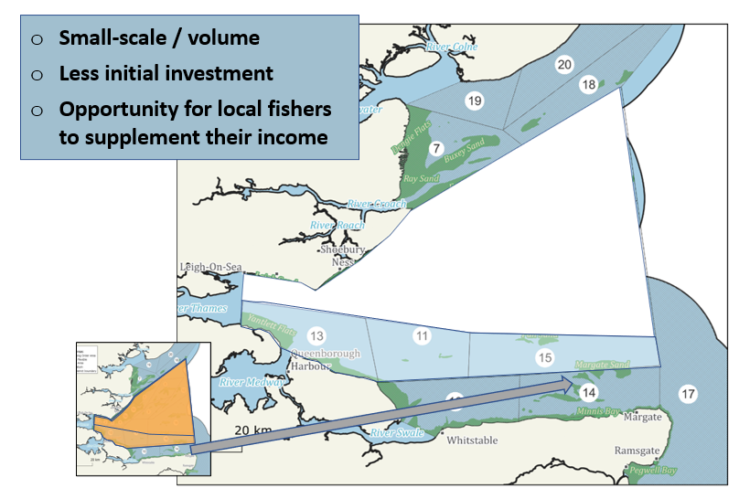

Background
The feedback from Consultation 1 generally supported the development of a small-scale fishery. This built upon comments in the Listening Phase that the current permit fishery does not work, because of a fleet which is too big for the available grounds, each taking too large a quantity of cockles per fishing trip. Rather than run a small-scale fisheries trial in the areas outside a new Regulating Order, the Authority agreed to progress the development of a small-scale fishery using the current flexible permit byelaw.

Running the permit fishery as part of an overall framework
Outside of the proposed new Regulating Order, all the options discussed in this consultation document include the same management system and commitment to develop an effective small-scale cockle fishery. For the NEW HAITI and NEW BERMUDA options the boundary of the permit byelaw would continue to follow the current TECFO boundary and would contain the relatively consistent and productive beds of the Buxey and the Dengie (Area 7) as well as the much smaller and inconsistent cockle beds in Minnis Bay (Area 14) and Pegwell Bay (Area 17). The NEW JAMAICA option however, redraws the southern boundaries so that the Margate Sands (Area 15) and Scrapsgate (Area 13) would be included in the new permit fishery from 2025 (see Comparing the Options section for more detailed information).

Way forward
This is a very different task and poses different challenges compared to creating a new Regulating Order as the Regulating Order has clearly established business models and fishing methods, whereas the permit fishery needs to establish workable business models and new fishing methods as a first step. The aim of the permit fishery is to create a long-term opportunity for the inshore sector that seeks to provide a reliable and regular income and be an addition to the fisheries they currently work in. The questionnaire in Appendix 4 seeks to consult on a range of options as to how the permit fishery will be run in 2023. Whilst the final management decisions for this fishery will be made in May 2023 after the stock survey, the feedback from this consultation will allow KEIFCA to set out the broad outline of how the fishery will be run, which in turn might help fishers decide whether to apply for a permit by the 31st March 2023. KEIFCA is exploring a range of different potential ways to use the current byelaw to manage the fishery over the coming years and the following are areas which are being explored.

Categories of permit
- Category 1 and Category 2 permits issued
Permits would be issued to all applicants either as category 1 or category 2. Category 1 permits would be limited to no more than 6.8m3 or 6 bags of cockles per trip, category 2 permits would be limited to no more than 1.7m3 or 1.5 bags of cockles per trip, and in addition would be permitted to undertake twice the number of trips as a category permit. This would result in each category 2 permit landing a maximum of half the amount landed by a category 1 permit.
- Just Category 2 issued
Only applications for category 2 permits would be accepted, any category 1 permit applications would be rejected, and the applicant invited to apply for a category 2 permit. All vessels would be limited to the same quantity per trip, either 1.7m3 (1.5 bags) or 3.4m3 (3 bags) of cockles per trip and the TAC would be split equally to provide the same number of trips for each permit holder.

When to fish?
Targeting a time of year for when the fishery is at, or close to, peak yields is important to achieve the best economic return and therefore viability for the fishery. The permit fishery has, in recent years, been undertaken in mid-October. It is suggested that bringing this forward to late summer between early September and mid-October would improve the viability of the fishery for vessels.

Different start times
If two categories of permit are issued, then category 1 vessels and category 2 vessels would be given different specified fishing times. This could take one of a number of forms, from a delayed start time for category 1 vessels, to two distinct and separate fishing periods for each category, or a long stretched out fishery for category 2 vessels and a short, intense fishery for category 1 vessels.

Reducing permit fishery fleet size
Reducing the size of the fleet working on the permit fishery would firstly enable smaller areas of cockle bed to be opened as the fleet would be taking less cockles per trip. Secondly, it would enable more trips of the fleet to be carried out on larger beds, helping to make the fishery more economically viable. Restricting the ability of the fleet which fishes the Regulating Order to access the permit fishery would reduce the size of the fleet considerably. The average fleet size over the past 11 years has been 34 vessels, this could be reduced to 20 vessels by removing the current TECFO fleet.

Clam fishery
Clams have been found in increasing quantities in a number of cockle harvesting areas in recent years. They are found primarily in Area 7 off the Essex coast, however smaller quantities are being found on the north Kent coast, especially around the Isle of Grain. Whilst they are not currently commercially harvested within the District, there is the potential for a fishery if MPA and food health requirements can be met. However, it is the industry’s responsibility to ensure that the other requirements for landing shellfish such as only taking stock from waters which are classified for those species are complied with via the relevant regulators. If this is done, then the next step would be for the industry to report the quantities, using their existing catch return forms, that they are removing of species other than cockles. This will help KEIFCA develop appropriate management for future years.

Comparing the options
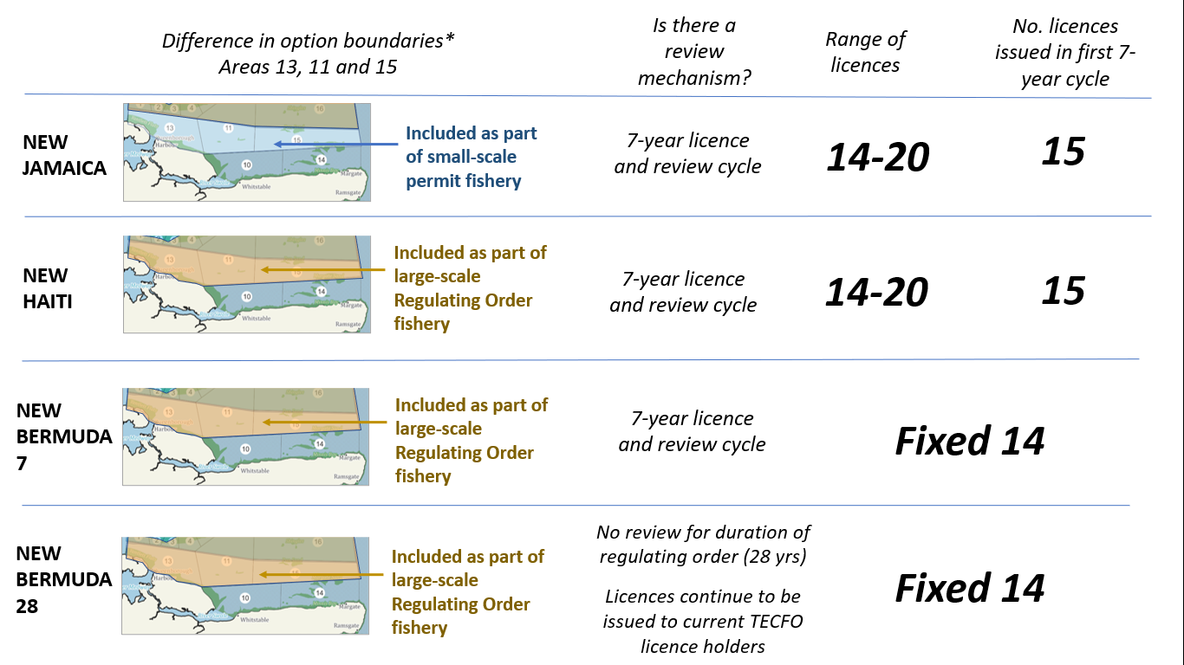

The impact of the difference in option boundaries
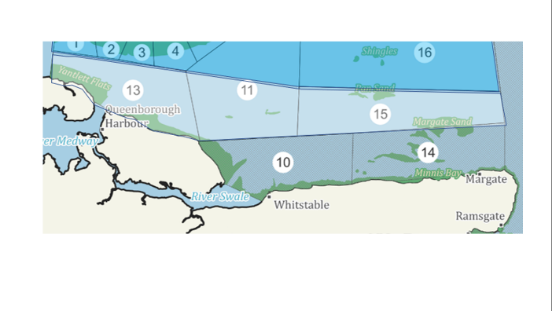
The proposed NEW JAMAICA regulating order boundary and the proposed NEW HAITI/ NEW BERMUDA regulating order boundaries follow the current TECFO boundary, apart from the Southern boundary which is positioned further north in the NEW JAMAICA option. In all of the options, the area outside the regulating order would be managed under a flexible permit byelaw, outside of the regulating order licensing regime, and would be set-up for a small-scale, part-time fishery rather then the large scale/ large volume fishery. This means there are a series of cockle areas (including the Margate Sands - Area 15 and Scrapsgate - Area 13) that would be included in the new regulating order under the NEW HAITI/ NEW BERMUDA options and in the permit byelaw area under the NEW JAMAICA option.
Whereas a byelaw can be significantly changed and remade within 18 months to 2 years, a Regulating Order is made by act of parliament and once made is extremely difficult to change, effectively meaning that once the boundary and the framework of the new regulating order is agreed it is likely to stay the same for the duration of the regulating order i.e. for the next 28 years.
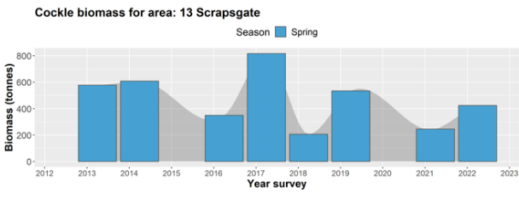
Area 13
Although cockles are found along the coastline around the Isle of Grain and the Isle of Sheppey, the main cockle beds in Area 13 are found along Sheerness beach and the Scrapsgate area. These beds produce significantly less cockles than areas like the Maplin Sands (Areas 4,5 and 6) and the cockle surveys have shown the cockle stock biomass from this area has been inconsistent, however cockles are harvested at a low level by some of the current TECFO fleet in most years. Clams have been found in Area 13 although in small quantities.
Area 11
This area consists of mobile sandbanks and includes the East Cant, Middle and Red Sands. Cockles have not been fished in any significant quantities in this area and no surveys have been carried out in this area in the last decade.
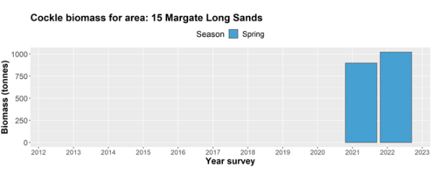
Area 15
Until the last few years, these beds were previously fished commercially over 20 years ago. The Margate Sands are more exposed and dynamic than some of the sand banks closer to the mouth of the Thames and the cockles are found in dense but highly productive patches. Compared to other areas KEIFCA does not have the same long-term stock data to help inform management and at present the area is considered to contain potentially very high yielding but highly variable cockle beds. The high yielding nature of these beds means the cockles found in this area have fetched a much higher price, compared to cockles from the rest of the Thames.
For more see the Spatial Distribution and Stock Review of cockles in the Kent and Essex district Report for more detailed information on our consultation website http://cocklereview.kentandessex-ifca.gov.uk/.

Retrofitted available adult stock comparison – Outer Thames Regulating Order 2025
Using historic management data it is possible to illustrate the potential adult cockle stocks that could have been available to the OTRO under each of the proposed options over the last 11 years.

The amount of available adult stock (AAS) is calculated each year and is based on over 1,200 cockle samples. The TAC set from this assessment, along with other yearly management measures, is discussed and agreed at the May Authority meeting each year. TAC is then divided equally between the number of licences issued in the regulating order. Under the NEW BERMUDA 7 & 28 options the AAS is divided by 14 licences, and under the NEW HAITI and NEW JAMAICA options the AAS is divided by 15 licences. In 2020 the pronounced drop in the NEW JAMAICA AAS compared to the NEW HAITI AAS is due primarily to cockles from Area 15 – the Margate Sands being part of the permit fishery rather than the regulating order. On average the AAS per licence would be 6.7% less per licence for a licence under the NEW HAITI option compared to the NEW BERMUDA 7 & 28 options, and 9.25% less per licence under the NEW JAMAICA option compared to the NEW BERMUDA 7 & 28 options. The cockle fishery is a very dynamic and fluctuating system that is very hard to predict over the 11 years and the total fishery TAC during that period has been as high as 8,008 tonnes and as low as 3,838 tonnes, a +20%/-58% difference from the 11-year average of 6649 tonnes. The analysis included in this report should be used as a basic illustration and should be considered along with the Seafish - Economic Performance Report and the Review of environmental impacts of hydraulic suction dredging for cockles - KEICFA district report. Both these documents are available on our consultation website http://cocklereview.kentandessex-ifca.gov.uk/.

Retrofitted available adult stock comparison – Small-scale flexible permit fishery
Using historic management data it is possible to illustrate the potential adult cockle stocks that could have been available to the small-scale flexible permit fishery, if all areas containing cockles could be worked, under each of the proposed options over the last 11 years.

The amount of available adult stock (AAS) is calculated each year. The TAC set from this assessment, along with other yearly management measures, is discussed and agreed at the May Authority meeting each year. TAC would then divided equally between the number of permits applied for during that year. The above figure doesn’t attempt to show the AAS per vessel as the number of permits issued varies significantly each year.
The absence of stock in the New Bermuda and New Haiti options in 2020 is a result of limited surveys resulting from COVID restrictions during that year. However the remaining data suggests that New Jamaica would result in an annual increase of AAS between 6% and 60% when compared to the New Bermuda or New Haiti options.

Questionnaire
Collecting information about you and your background is important to us as it helps us better understand your point of view. Items with an asterisk * are mandatory questions as they help us validate all of the responses that we get.

Personal Information
*Name |  | Click or tap here to enter text.
*Address |  | Click or tap here to enter text.
*Email |  | Click or tap here to enter text.
*Phone |  | Click or tap here to enter text.
*Age range |  | Choose an item.
*Area of interest |  | Choose an item.
*Are you responding on behalf of a company/organisation? If so, please specify. |  |  |  |  | Yes ☐ No ☐
Company/Organisation: Click or tap here to enter text.
*Do you currently work, or have you previously worked, in the cockle industry? |  |  |  |  | Yes ☐ No ☐
If yes for how long and in what role(s)?
Role/Job | Owner |  | Skipper | Crew |  | Processor
Length of time (years) | Click or tap here to enter text. |  | Click or tap here to enter text. | Click or tap here to enter text. |  | Click or tap here to enter text.
Would you apply for a permit/ licence if a new application process was available? |  |  |  |  | Yes ☐ No ☐
*Do you have access to licenced fishing boat as an owner and/or skipper? |  |  |  |  | Owner ☐ Skipper ☐ No ☐
*If owner or skipper, please specify the boat name and PLN |  |  |  |  | Click or tap here to enter text.
Can the licenced fishing boat you have specified be rigged up with fishing gear suitable for cockle harvesting? |  |  |  |  | Choose an item.
*Which of the following categories best describes you? Please tick all that apply.
TECFO |  | CFFPB (Permit Fishery) |  | Other catching sector |  | Other sector
TECFO Company Director | ☐ | Permit Holder - KEIFCA area | ☐ | <10 KEIFCA fisherman | ☐ | Processor | ☐
TECFO Representative | ☐ | Permit Crew - KEIFCA area | ☐ | >10 KEIFCA fisherman | ☐ | Processor | ☐
TECFO Deputy | ☐ | Permit Holder - other area | ☐ | <10 Other area fisherman | ☐ | Other | ☐
TECFO Crew | ☐ | Permit Crew - other area | ☐ | >10 Other area fisherman | ☐ | Other | ☐

Preferred option
- Tick your preferred option | NEW JAMAICA ☐  NEW HAITI ☐  NEW BERMUDA 7-year review ☐  NEW BERMUDA 28-year entitlement ☐

- Briefly outline why this is your preferred option
Click or tap here to enter text.

Comparing the options
- Please rank the options 1-4 (1 = best option, 4 = worst option)
NEW JAMAICA Click or tap here to enter text.

NEW HAITI Click or tap here to enter text.

NEW BERMUDA 7-year review Click or tap here to enter text.

NEW BERMUDA 28-year entitlement Click or tap here to enter text.

- Briefly outline your reasons or rationale for your ranking order
Click or tap here to enter text.

Advantages and disadvantages of each option

- What do you see as the advantages and disadvantages of each option with regards to “creating a well-managed fishery”? Use the evaluation questions below as a guide.
- Does the option provide a simple framework that is easy for fishers, Authority members and other stakeholders to understand and work within?
- Will the option be easy and cost-efficient to administer, and not create too much paperwork for applicants to fill in?
- Will the option help create clear rules and regulations and be straightforward for KEIFCA officers to enforce and fishers to comply with?
 | Advantages | Disadvantage
NEW JAMAICA | Click or tap here to enter text. | Click or tap here to enter text.
NEW HAITI | Click or tap here to enter text. | Click or tap here to enter text.
NEW BERMUDA 7 | Click or tap here to enter text. | Click or tap here to enter text.
NEW BERMUDA 28 | Click or tap here to enter text. | Click or tap here to enter text.

- What do you see as the advantages and disadvantages of each option with regards to “creating an environmentally responsible fishery”? Use the evaluation questions below as a guide.
- Does the option help ensure the cockle stock population is fished within clear limits that consider stock assessments and breeding stock?
- Does the option help assess and monitor the impact of the fishery on the seabed, and strive to make the impact as small as possible?
- Does the option help consider the impact of the cockle fishery management on the wider ecosystem (including carbon footprint) and support internationally recognised accreditation systems (e.g. Marine Stewardship Council)?
 | Advantages | Disadvantage
NEW JAMAICA | Click or tap here to enter text. | Click or tap here to enter text.
NEW HAITI | Click or tap here to enter text. | Click or tap here to enter text.
NEW BERMUDA 7 | Click or tap here to enter text. | Click or tap here to enter text.
NEW BERMUDA 28 | Click or tap here to enter text. | Click or tap here to enter text.

- What do you see as the advantages and disadvantages of each option with regards to “helping to support a successful and resilient local coastal economy”? Use the evaluation questions below as a guide.
- Does the option provide a framework that will help sustain a viable long-term cockle industry in the KEIFCA district?
- Will the option help support local skilled employment?
- Will the option help assist long-term investment and growth in the local economy, supporting local shore side infrastructure and supply chains?
- Will the option help to ‘add value’ to the cockles that are caught in the cockle fishery?
 | Advantages | Disadvantage
NEW JAMAICA | Click or tap here to enter text. | Click or tap here to enter text.
NEW HAITI | Click or tap here to enter text. | Click or tap here to enter text.
NEW BERMUDA 7 | Click or tap here to enter text. | Click or tap here to enter text.
NEW BERMUDA 28 | Click or tap here to enter text. | Click or tap here to enter text.

- What do you see as the advantages and disadvantages of each option with regards to “strengthening and supporting our dynamic local coastal community”? Use the evaluation questions below as a guide.
- Does the option provide fair opportunities for individuals and businesses, and help support young or new fishers?
- Does the option help encourage businesses to invest in a safe and skilled workforce?
- Does the option help support the heritage and culture of the cockle fishery, including supporting local tourism associated with the Thames cockle fishery?
 | Advantages | Disadvantage
NEW JAMAICA | Click or tap here to enter text. | Click or tap here to enter text.
NEW HAITI | Click or tap here to enter text. | Click or tap here to enter text.
NEW BERMUDA 7 | Click or tap here to enter text. | Click or tap here to enter text.
NEW BERMUDA 28 | Click or tap here to enter text. | Click or tap here to enter text.

Feedback on detail of application systems

7- year review (New Jamaica, New Haiti and New Bermuda 7)
- Do you have any comments regarding the length of time of each licence cycle? Do you think they should be longer or shorter? If so why?
Click or tap here to enter text.

- Do you have any comments regarding the criteria used to evaluate licence applications?
Relevant experience of cockle fishing in the Thames (TECFO - track record) | Click or tap here to enter text.
Relevant experience of cockle fishing in the Thames (Permit fishery - track record) | Click or tap here to enter text.
Relevant experience of fishing in the Thames. (General fisheries) | Click or tap here to enter text.
Relevant experience cockle fishing outside the KEIFCA district but with the UK | Click or tap here to enter text.
Evidence of cooking cockles caught in the Thames in factories with the KEIFCA district | Click or tap here to enter text.
Evidence showing company supporting skilled local employment, apprenticeships or equivalent | Click or tap here to enter text.
Evidence showing company supporting local supply chains | Click or tap here to enter text.
Examples of the steps the company adding value to landings | Click or tap here to enter text.
Examples of company taking steps to reducing impact of gear on both the cockle stocks and on the seabed | Click or tap here to enter text.
Examples of company taking steps to reduce CO2 emissions | Click or tap here to enter text.
Examples of company taking steps to support the wider community | Click or tap here to enter text.
Compliance track record | Click or tap here to enter text.

- Are there criteria you think we should add or remove?
Click or tap here to enter text.

- Would there be criteria would you weight higher or lower than others? Please explain why?
Click or tap here to enter text.

- Do you have any comments regarding the overall 7-year process?
Click or tap here to enter text.

28-year licence (New Bermuda 28)
- Do you have any comments regarding the issuing of a 28-year licence? Do you think it should be longer or shorter? If so, why?
Click or tap here to enter text.

- Do you have any comments regarding the criteria used to issue a licence?
Click or tap here to enter text.

- Do you have any comments regarding the overall process of issuing licences?
Click or tap here to enter text.

Number of licences issued
- Do you have any comments regarding the proposed number of 15 licences to be issued for the first 7-year cycle as outlined in the NEW JAMAICA option?
Click or tap here to enter text.

- Do you have any comments regarding the proposed number of 15 licences to be issued for the first 7-year cycle as outlined in the NEW HAITI option?
Click or tap here to enter text.

- Do you have any comments regarding the fixed number of 14 licences to be issued for the duration of the 28-year regulating order as outlined in the NEW BERMUDA 7 option?
Click or tap here to enter text.

- Do you have any comments regarding the fixed number of 14 licences to be issued for the duration of the 28-year regulating order as outlined in the NEW BERMUDA 28 option?
Click or tap here to enter text.

Final comments
- Do you have anything else you would like to comment on or say?
Click or tap here to enter text.

Appendix 1 Detail of the 7-year licencing and review cycle
In developing the structure for a new regulating order there are two important questions that need to be answered how often the Authority will review the number of licences it issues under the regulating order and following on from this how long a licence would last for. KEIFCA members reviewed a range of different cycle lengths from annual cycles to 10-year review cycles.
The challenge with reviewing and then issuing licences on an annual basis are many and significant, but centre around the difficulties that businesses would face in a system where the number of licences issued to fish could vary significantly from one year to the next and only be known 1 to 2 months before the fishery would be opened. Business and investment planning would be especially difficult in such a fluctuating system.
The Authority members therefore reviewed a range of longer cycles and considered the evidence and process the Authority could use to review and then issue licences. Longer cycles provided business with a longer time to invest and to monitor impacts but reduced the ability and opportunity to change and modify the number of licences. The Authority arrived at a 7-year cycle as a balance between these competing demands.
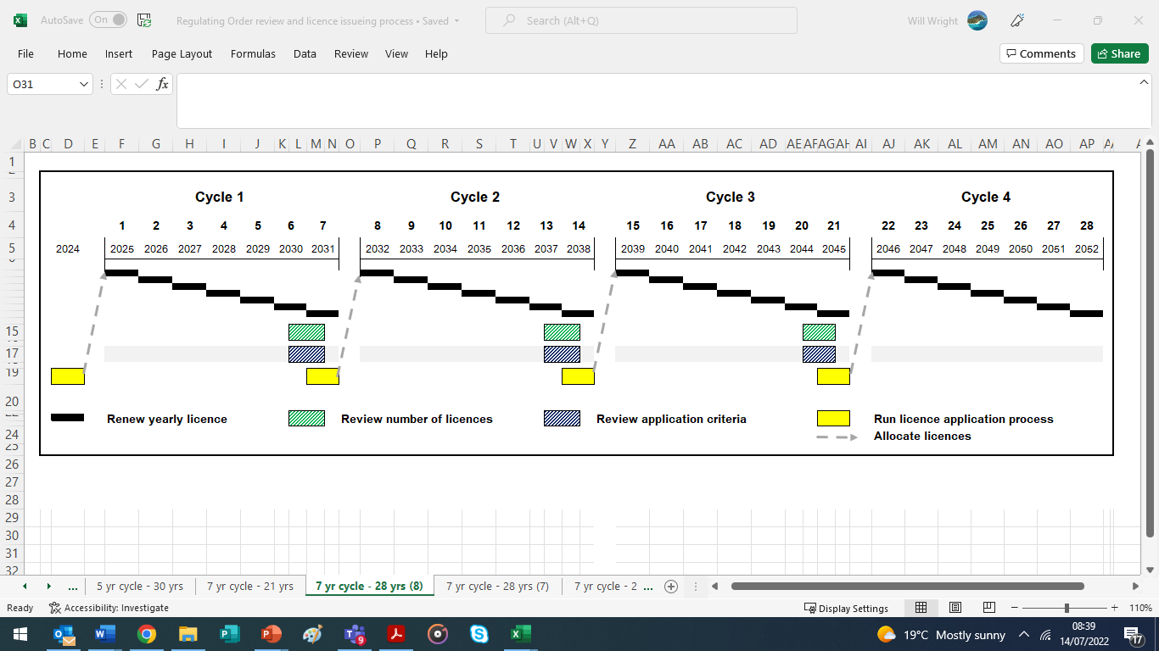
The new regulating order would be designed to run for 28 years (2025 - 2053) and be split into four 7-year licencing cycles. Licences would be renewed and issued annually to the same licence holders from year 1 to year 7 in each cycle, in the same or a similar way to how they are under the TECFO 1994 system. The licence application process for the following 7-year cycle would take place in the year prior to the start of each cycle (See Appendix 3 for mor details). Before starting the licence application process KEIFCA will review and agree both the number of licences it will issue in the next 7-year cycle as well as the application criteria weighting, and process applicants will use to apply for a licence. Both reviews will assess all relevant information and ask stakeholders for feedback on any proposed changes.
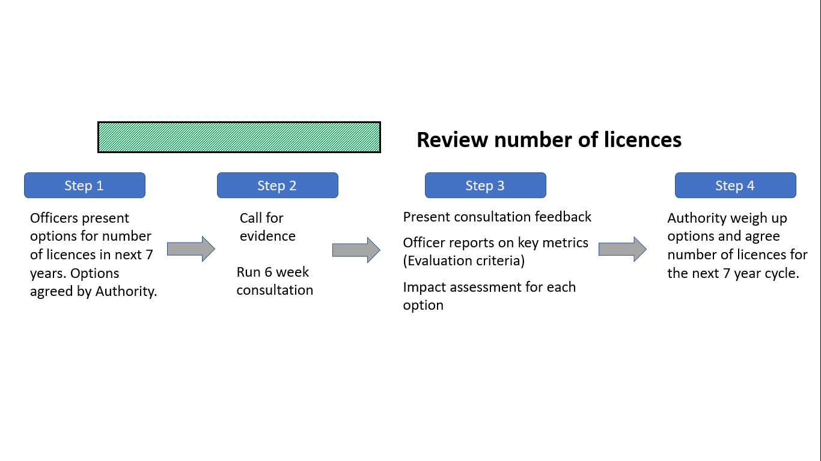
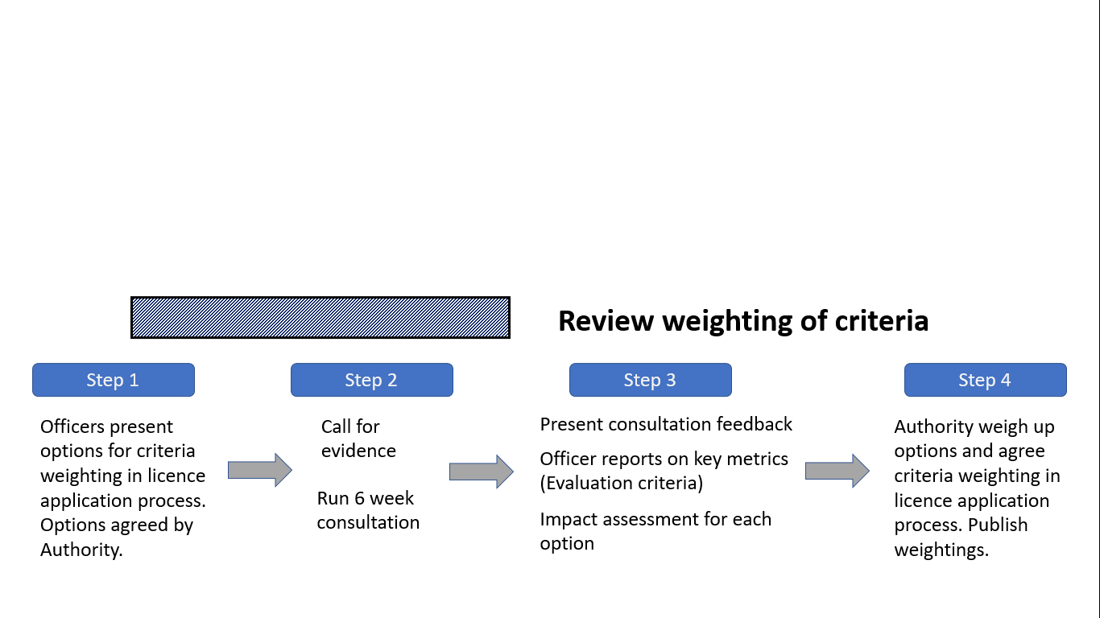

Appendix 2 Detail of the licence application process
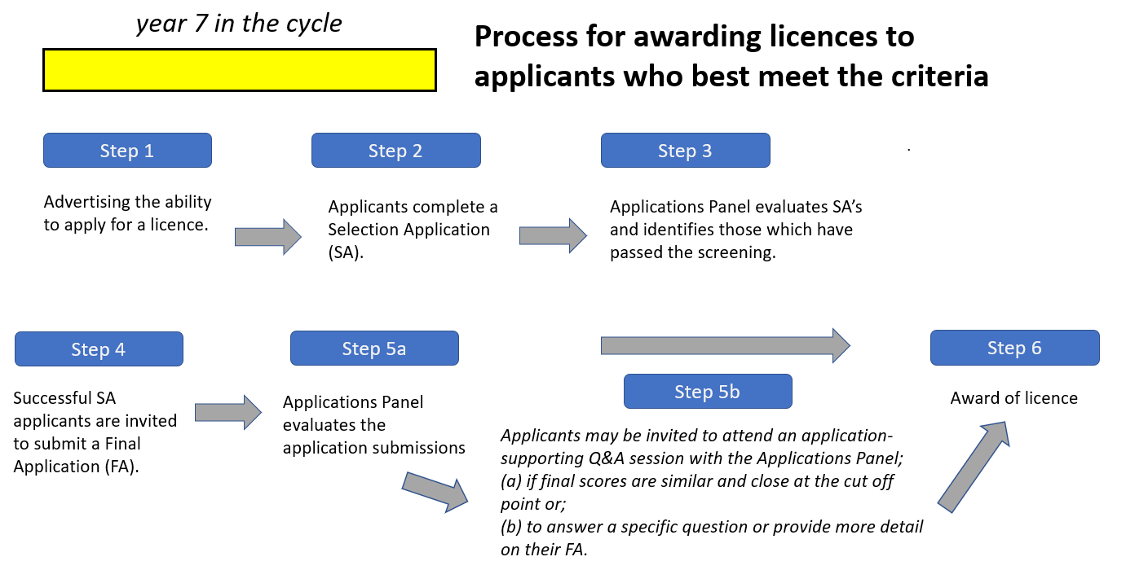
The process and framework for issuing licences under the new regulating order was always going to result in difficult and controversial decisions being made as KEIFCA recognises that it is highly likely that there will be more applications than licences issued, which will leave some applicants disappointed.
KEIFCA works closely with Kent County Council (KCC), and the Council has significant experience and expertise in running different licence application processes. The intention is to work with a specialist team at KCC who develop processes to issues licenses for wide range of other sectors from taxi licensing to waste disposal licences and are used to working with different types and sizes of businesses. Using KCCs standard process, the first step would be to advertise the opportunity to apply for a licence, with applicants required to complete a Selection Application (SA). An Applications Panel would then screen and evaluate the questionnaires, with successful applicants invited to make a far more detailed Final Application (FA).
The Applications Panel would evaluate and score the FA submissions against clear published criteria in specified categories. Each citerion will be assigned a weighted score, weighting the scores means that criteria which the Authority decides have a higher priority attract a higher score then those criteria which have a lower priority. Total scores will be used to rank applications and licences would be awarded in descending scores order starting with those with the highest scores until all available licences have been issued.
If the final scores are the same or similar for two or more applications and at the cut-off point where applicants would or would not receive a licence, the relevant applicants would be invited to a special meeting of the Applications Panel and asked to orally run through their application and answer questions on their application from the Panel. Application Panel members would then carry out an additional scoring of those applications. The Applications Panel could also invite an applicant to attend and answer a specific question or add specific detail from a section of the application.

Appendix 3 The criteria used to evaluate applications
Traditionally the fishing rights or licences have been allocated to fishers that can prove they worked in a fishery over a given period. This approach is especially difficult when the current TECFO creates a limited entry fishery, resulting in excluded fishers being unable to create a track record. The current Cockle Fishery Flexible Permit Byelaw (CFFPB) has very basic entry requirements and provides another possible avenue for a track record approach, however there are a significant number of permit holders with near identical track records and transferring this into a ranked list of applicants does not work as too many applicants are on the same ranking score.
Working with Kent County Council, there is the opportunity to develop new application criteria that build on the feedback and priorities identified in the Listening Phase and allow applications to be ranked against these priorities. Due to the detail involved, the relative weightings of different criteria and the scoring scale of each criterion would be addressed in detail in Consultation 3, if either the NEW JAMAICA, NEW HAITI and NEW BERMUDA 7 options were selected. It would then be the Authority’s intention to develop 2-3 application frameworks each with different criteria weightings and consult on these options as part of the Consultation 3 process.
Category | Criteria | Rationale
Experience | Relevant experience of cockle fishing in the Thames (TECFO - track record) | Each of these criteria allow applicants to show that they have experience of fishing for cockles and/or fishing within the KEIFCA District. Having separate criteria for fishing within a regulating order, under a permit byelaw, general fishing within the District and fishing for cockles elsewhere allows applicants who have not fished in the regulating order prior to their application to provide evidence that if given the opportunity to do so that they have the experience to do so successfully and in compliance with all relevant legislation.
Experience | Relevant experience of cockle fishing in the Thames (Permit fishery - track record)
Experience | Relevant experience of fishing in the Thames. (General fisheries track record)
Experience | Relevant experience cockle fishing outside the KEIFCA district but with the UK
Experience | Compliance track record
Socio-economics | Evidence of cooking/processing cockles caught in the Thames in factories with the KEIFCA district | Processing within the District maximises the economic return within the local community of harvesting cockles, rather than the catching operation being the sole source of economic return. Even a small cooking plant can triple the number of employees within a company compared to the number employed solely within the catching operation of a cockle vessel. Further processing operations may increase this again. This criterion allows the applicant to show that they are investing in the fishing sector at a level which is wider than just catching cockles and then removing any future socioeconomic benefits to other areas outside of the KEIFCA District.
Socio-economics | Evidence showing company supporting skilled local employment, apprenticeships or equivalent | This criterion allows an applicant to show that they are creating opportunities for local employment and is encouraging new entrants into the fishing industry, with a particular focus on recruitment of younger fishers.
Socio-economics | Evidence showing company supporting local supply chains | Whilst the cockle industry is relatively small, a large range of other companies, services and suppliers are required in supporting the fleet. This criterion allows applicants to show that they are sourcing as much of their supporting functions as possible from local suppliers.
Socio-economics | Examples of the steps the company adding value to landings | The way that cockles are handled, processed, sold and under what certification can change the financial return of a fixed quantity of cockles. This criterion allows an applicant to show how they are maximising the value of their catch.
Socio-economics | Examples of company taking steps to support the wider community | Whilst the harvesting of cockles is undertaken by a limited number of individuals, the fishery remains a public asset. This criterion allows an applicant to show how they support the wider community of people who are not directly involved with the fish catching sector.
Environmental Impact | Examples of company taking steps to reducing impact of gear on both the cockle stocks and on the seabed | Bottom towed gear does have an impact on the seabed, however the suction dredges used in the cockle fishery are the method with the greatest efficacy within the Thames. This criterion allows applicants to show how they are continually improving the fishing gear used in the fishery to minimise its impact upon the seabed and the cockles left on the beds after fishing.
Environmental Impact | Examples of company taking steps to reduce CO2 emissions | This criterion allows applicants to show how they are reducing their carbon footprint and the wider environmental impact of their fishing operations.

Appendix 4 2023 small-scale fishery questionnaire

2023 KEIFCA Cockle Permit Fishery Questionnaire
This questionnaire is based on feedback from the Listening Phase and Consultation 1 of the KEIFCA Cockle Fishery Review and Development of Management Measures. That review has led to the Authority exploring different ways of managing the permit cockle fishery, outside the area of the Thames Estuary Cockle Fishery Order 1994. In the first instance this is being considered using the existing permit byelaw, with a focus on enabling a small-scale fishery in 2023 which provides an additional fishing opportunity for the inshore fishing fleet. As a result, this questionnaire is purposely stripped back and as simple as possible to try and enable engagement with an as-wide-as-possible cross-section of the fishing industry.
This questionnaire is regarding the 2023 cockle permit fishery. However, it is linked to the overall cockle fishery review which is currently taking place. We would strongly advise that you look at the review website (https://cocklereview.kentandessex-ifca.gov.uk) and consider the overarching process prior to completing this questionnaire.
How to respond to this questionnaire
Please email your completed questionnaire to info@kentandessex-ifca.gov.uk. The closing date for receipt of questionnaires is 16th September 2022.
*Name | Click or tap here to enter text.
*Address | Click or tap here to enter text.
*Email | Click or tap here to enter text.
*Phone | Click or tap here to enter text.
*Are you responding on behalf of a company/organisation? If so, please specify. |  | Yes ☐ No ☐
Company/Organisation: Click or tap here to enter text.
*Do you have access to licenced fishing boat as an owner and/or skipper? |  | Owner ☐ Skipper ☐ No ☐
*If owner or skipper, please specify the boat name and PLN |  | Click or tap here to enter text.

Q1. Do you intend to apply for a permit to fish for cockles outside of the TECFO in 2023? If so, which category of permit are you likely to apply for?
Category 1 ☐ Category 2 ☐ Likely to not apply ☐

Q2. Do you think TECFO-licensed vessels should fish for cockles outside of the TECFO in 2023?
Yes ☐ No ☐

Q3. Yields are generally better in the late summer period. We will aim to try and open the fishery when yields are at their best. As a result, the suggested start date for the fishery is in early September. Do you agree with this?
Yes ☐ No ☐
If ‘No’ please say why and provide your alternative suggested time for opening the fishery.
Click or tap here to enter text.

Q4. Given the aim is for a ‘small-scale’ fishery, should all vessels be restricted to the same tonnage of cockles per trip?
Yes ☐ No ☐
If yes, what amount should all vessels be limited to?
6 tonnes ☐ 3 tonnes ☐ 1.5 tonnes ☐ Other ☐
If ‘No’, what should the maximum tonnage be for each category of permit?
Category 1 6 tonnes ☐ 3 tonnes ☐
Category 2 3 tonnes ☐ 1.5 tonnes ☐

Q5. Should Category 1 and Category 2 vessels be given different times/periods to fish?
Yes ☐ No ☐
Please give the reason for your answer
Click or tap here to enter text.

Q6. If you answered ‘Yes’ to Q4, do you think that Category 2 vessels should be allowed to
- Start the day before category 1 vessels ☐
- Start the week before the category 1 vessels ☐
- Have a longer period to fish in than the category 1 vessels (i.e. start before and finish after the Category 1 vessels). ☐
- Fish at a completely different time to the category 1 vessels ☐

Q7. Would you be interested in catching clams as bycatch on cockle fishery trips or do you just want to catch cockles?
Cockles only ☐ Cockles and Clams ☐

Q8. Do you have any other comments regarding the 2023 cockle permit fishery or extra details to add on any of the above?
Click or tap here to enter text.

